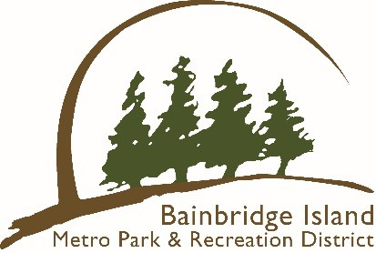

BAINBRIDGE ISLAND METRO PARK & RECREATION DISTRICT PADDLECRAFT STORAGE PROGRAM

There are 6 parks that will have space available for storage – please see our website for more information. You will be assigned a park and the storage is not portable. Each space is designed for a single paddle craft, and renters may choose any available space between the signs. Owners are responsible for securing their own craft.

1. Paddle craft stored outside the designated area will be removed at the owner’s expense.
2. All paddle craft must be seaworthy. Any paddle craft not deemed to be in such condition may be removed.
3. You may not loan out or sublease your space.
4. Each space rents for $75 per year/season for Bainbridge Island residents. There will be no proration of fees. There will be no refunds if the renter voluntarily discontinues use of the storage space during the year.
5. For information on the locations, storage, or how to reserve a space, visit the Park District’s website at biparks.org.
6. If for any reason we ask you to remove your paddle craft, you will need to do so within a ten-day period If the paddle craft is not removed, the Park District will remove the paddle craft and store for 30 days. After that time, it will be disposed of per Park District policy.
7. We reserve the right to end the program at any time based on Park District needs.

FREQUENTLY ASKED QUESTIONS

1. How to I register my paddle craft?
   1. You can go online and reserve your spot at [www.biparks.org/register](http://www.biparks.org/register)
2. How long is this reservation good for?
   1. One year or until the end of the season. Some sites are seasonal; please check the website for more information.
3. Do I have to place the sticker on my paddle craft?
   1. Yes, staff will be removing paddle craft that do not have the registration sticker on it.
4. Once I sign up, how do I get the sticker?
   1. Once you sign up online and pay, you will be mailed a sticker.
5. Can I register at the office?
   1. All registration will be on the Park District website or by mail.
6. What type of paddle craft can be stored?
   1. Canoe, kayak, and stand-up paddle boards.
7. What if the sites fill up?
   1. Every January there will be a new opportunity to register, first come first serve.

THE DISTRICT IS NOT LIABILE FOR ANY DAMAGE OR LOSS THAT MAY OCCUR DUE TO WEATHER, VANDALISM, THEFT OR OTHER MEANS.