*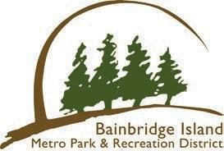*

Bainbridge Island Metropolitan Park & Recreation District

Program for — Parks

Paddlecraft Storage Program

Division: Park Services Purpose

This program clarifies *the Paddlecraft Storage Program rules* and is needed to ensure beaches are kept orderly and monitored.

Scope

The District recognizes the benefit of providing public storage facilities that provide shoreline access while protecting and maintaining the beauty of the shoreline.

Procedures

1. *Potential renter should go to the District website to rent a space. Once the space is paid for, a decal/sticker will be mailed to the renter so they can clearly identify their craft with registration number, name, and phone number on site.*
2. *The renters can choose from the available spaces to store their craft (on the District website).*
3. *Renters will be charged a $75 annual fee for use of the site. There will be no proration of rental fees. Use will be on a first come, first serve basis.*

*Sites are:*

1. *Blakely Harbor Park*
2. *Fay Bainbridge Park*
3. *Fort Ward Park*
4. *Point White Pier*
5. *Manitou Beach*
6. *Schel Chelb*

1. *Once approved, patrons can store their boats at the selected site utilizing the posted rules.*