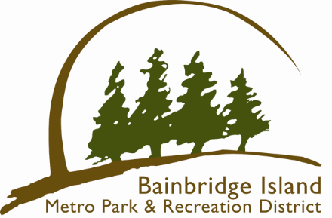
Bainbridge Island Metropolitan Park & Recreation District
Fay Bainbridge Park Campground Host
Agreement
Duties and Responsibilities:

In exchange for RV space occupancy and utilities (water, sewer, Wi-Fi, and electrical), the campground host at Fay Bainbridge Park agrees to perform the following duties at Fay Bainbridge Park. This contract can be broken by either party for any or no reason. The contract is for one month and may be extended upon agreement by both parties.
Primary Duties:
- Inform Visitors and Guests of Park Rules
- Serve as after hours and weekend host of campground
- Serve as public contact for Park District to answer questions
- Provide aid with check-in procedures and reservations
- Litter patrol of park grounds and clean as needed
- Garbage and Recycling collection and hauling (Must be able to lift 50 pounds)
- Clean and restock restrooms routinely as needed
- Cabin cleaning as needed
- Occasionally inspect and clean campsites as needed
- Keep Campground Coordinator informed of any issues
- Must contact Campground Coordinator during emergency situations
- Other duties as assigned or agreed upon
I have read and agree to perform the above Camp Host(s) duties:
Signature Camp Host: ______________________________________________
Print Name: ______________________________________________
Phone #: ______________________________________________
Date: ______________________________________________

Signature Camp Coordinator: ______________________________________________
Print Name: ______________________________________________
Date: ______________________________________________

