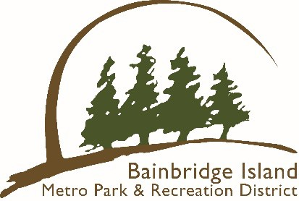

Bainbridge Island Metro Park & Recreation District

Paddle Craft Storage Program Rules

- Paddle crafts must be stored at one of the District’s designated storage sites.

- Permit holders must store their paddle craft at the park their permit is registered for.
- Each space is designed for a single paddle craft, and renters may choose any available space between the signs.
- Owners are responsible for securing their own craft.
- Paddle craft stored outside the designated area will be impounded and incur a $100.00 impound fee.
- All paddle craft must be seaworthy. Any paddle craft not deemed to be in such condition may be impounded or disposed of. Impounded paddle craft may be retrieved for a $100.00 impound fee.
- You may not loan out or sublease your space.

- Bainbridge Island residents can rent a space for $100.00 per year/season. Fees cannot be prorated. Refunds are not available if the renter voluntarily discontinues use of their storage space.

- Non-compliant paddle crafts will be cited for removal. Permit holders must remove their paddle craft within a ten-day period. If the paddle craft is not removed, the Park District will impound the paddle craft for 90 days. After that time, it will be disposed of.

- For information on the locations, storage, or how to reserve a space, visit the Park District’s website at biparks.org.

- The District reserves the right to end the Paddle Craft Storage Program at any time based on Park District needs.

FREQUENTLY ASKED QUESTIONS
Q: How do I register my paddle craft?
A: Spots may be reserved at www.biparks.org/register
Q: How long is my reservation good for?
A: One year or until the end of the season. Some sites are seasonal. Please check the website for more information.
Q: Do I have to place the sticker on my paddle craft?
A: Yes, staff will impound paddle craft that do not display a registration sticker.
Q: Once I sign up, how will I get my registration sticker
A: Once you’ve successfully registered for a rental space online, a sticker will be mailed to you.
Q: Can I register for a space at one of your offices?
A: Registration can be completed online at www.biparks.org.
Q: What types of paddle craft can be stored?
A: Canoes, kayaks, or stand-up paddle boards.
Q: What if registration is full?
A: Registration opens in January and is first come, first served.

THE DISTRICT IS NOT LIABLE FOR ANY DAMAGE OR LOSS THAT MAY OCCURE DUE TO WEATHER, VANDELISM, THEFT, OR OTHER MEANS.

