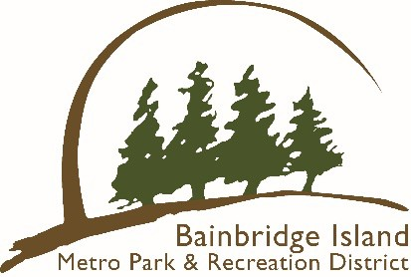
Bainbridge Island Metropolitan Park & Recreation District
Paddle Craft Storage Program

Division: Park Services
Purpose
This program clarifies the Paddlecraft Storage Program rules and is needed to ensure beaches are kept orderly.

Scope
The District recognizes the benefit of providing public storage facilities that provide shoreline access while protecting and maintaining the beauty of the shoreline.

Procedures
- Potential renters should visit www.biparks.org to rent a space. Once the space is paid for, a decal/sticker will be mailed to the renter so they can clearly identify their craft with registration number, name, and phone number on site.
- The renters can choose from the available spaces to store their craft (on the District website).
- Renters will be charged a $100 annual/seasonal fee for use of the site. Fees cannot be prorated. Use will be on a first come, first serve basis. Sites include:
- Blakely Harbor Park
- Fay Bainbridge Park
- Fort Ward Park
- Point White Pier
- Manitou Beach
- Schel Chelb Park

- Once approved, patrons can store their boats at the selected site utilizing the posted rules.
- Unpermitted paddle crafts or paddle crafts found in violation of the Paddle Craft Storage Program Rules will be impounded for 90 days and disposed of. Owners may retrieve their kayaks for a $100.00 impound fee within the 90-day impound period.

